DSCI 784 – Text Analytics Project
Title: Topic Modeling and Sentiment Analysis of BBC News Articles
Name: Victor Badu

1. Introduction

News media play a central role in shaping public understanding of social, political, and economic events. While news articles aim to communicate factual information , the tone, word choice, and framing embedded in the text can subtly influence how readers interpret what is being reported. Sentiment—whether positive, negative, or neutral—can vary widely across news categories, reflecting the nature of the events covered as well as editorial style. At the same time, large news collections often contain underlying thematic patterns that are not immediately visible without computational analysis.
Text mining provides a systematic way to uncover these patterns. Techniques such as sentiment analysis allow researchers to quantify emotional tone across documents, while topic modeling uncovers latent themes based on word co-occurrence structures. Together, these approaches help reveal not only what news stories are about, but also how they are communicated.
This project applies these methods to a corpus of BBC news articles with the objective of understanding two key aspects of the content:
- How sentiment differs across major BBC news categories, and
- What underlying topics emerge automatically when no labels are provided to the model.
The analysis focuses on five editorial sections of the BBC News website—business, entertainment, politics, sport, and tech—each of which represents a distinct domain of public interest. By combining sentiment analysis with topic modeling, the project aims to provide a deeper perspective on the linguistic and thematic structure of BBC reporting.

2. Objective and Purpose

The purpose of this project is to use text mining techniques to examine both the emotional tone and the underlying thematic structure of BBC news reporting. The analysis is designed to address three central objectives:
- Sentiment Analysis
- Measure the balance of positive and negative language within BBC news articles.
- Compare the average sentiment levels across the five editorial categories—business, entertainment, politics, sport, and tech.
- Identify which categories tend to exhibit more optimistic or pessimistic tones and what this may imply about the nature of reporting within each domain.
- Topic Modeling (LDA)
- Apply Latent Dirichlet Allocation (LDA) to uncover the latent themes present in the corpus without using predefined labels.
- Interpret the resulting topics and assess how well they align with the BBC’s existing editorial structure.
- Evaluate whether articles naturally cluster around the expected domains or whether cross-category thematic overlaps appear.

- Descriptive Text Analytics
- Generate descriptive statistics on the corpus, including document counts, word counts, and high-frequency terms.
- Provide visual representations of these distributions through bar charts, category-level word frequencies, and a global word cloud to illustrate key linguistic trends.
The final objective of the project is to identify at least one surprising or unexpected finding that emerges from the analysis and discuss its significance for understanding the tone, structure, or thematic patterns of BBC news content.

3. Text Acquisition

3.1 Corpus Source
The corpus used in this analysis is the BBC News Summary dataset, a publicly available collection hosted on Kaggle. The dataset consists of news articles originally published on the BBC News website and organized into five editorial categories:
- business
- entertainment
- politics
- sport
- tech
Each document is stored as a standalone .txt file within its respective category folder. The dataset was downloaded to the following local directory for processing:
C:/Users/victor.badu/Downloads/archive (7)/BBC News Summary/BBC News Summary/News Articles
This structure makes the dataset well-suited for text mining because documents are already separated into meaningful thematic groups, allowing for straightforward sentiment comparison and topic pattern discovery.

3.2 Data Import Process
The corpus was imported into R by iterating through each of the five category folders using list.files() to retrieve file names and readLines() to load the article text. A custom wrapper function automated this process by:
- Reading all .txt files within a category folder.
- Collapsing the lines of each file into a single text string.
- Storing the document along with its associated category label.
- Extracting the original file name as file_id (e.g., "001.txt").
Because BBC article filenames repeat across categories, a fourth identifier, doc_id, was generated by combining the category label with the file name (e.g., "business_001.txt"). This ensured that all documents had unique identifiers, which is essential for constructing a corpus object and performing topic modeling with LDA.
The final imported dataset consisted of 2,225 documents, each with clean metadata linking the article text to its category and unique document ID.

4. Text Preparation and Transformation

Effective text mining requires careful preparation of the raw corpus to ensure that the analytical methods operate on clean, meaningful, and comparable linguistic units. All preprocessing steps in this project were carried out in R using the tidytext, quanteda, and stringr packages. The purpose of these transformations is to reduce noise, standardize the text, and create structures suitable for sentiment scoring and topic modeling.

4.1 Descriptive Statistics
Before applying linguistic transformations, descriptive statistics were computed to understand the structure and distribution of the dataset. The corpus contains:
- 2,225 articles, distributed across five categories
- Average article length of ~2,259 characters
- Average word count of ~384 words
- More than 854,000 total words in the full dataset
A category-level bar chart (Figure 1) confirms that each BBC news section is well represented, supporting reliable category comparisons.
Figure 1: Distribution of Articles by Category
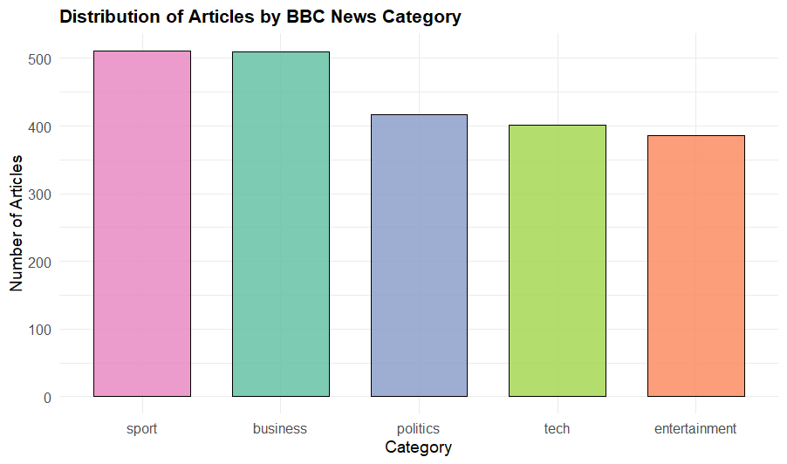
This balanced distribution supports reliable category comparisons and stable topic modeling.
4.2 Tokenization and Cleaning
To prepare the text for analysis, each article was converted into a “tidy” token format—one word per row—through the following steps:
- Lowercasing
All text was transformed to lowercase to prevent “Film,” “film,” and “FILM” from being treated as different words.
- Tokenization
Using unnest_tokens(), each article was split into individual word tokens. This creates a standardized structure for counting words, computing frequencies, and joining with sentiment lexicons.
- Stopword Removal
In addition to the standard English stopwords, several domain-general terms were manually added to the stopword list, including 'said' (a common reporting verb), 'new', 'also', and numeric words like 'one' and 'two'. These terms appear frequently across all categories but carry little category-distinguishing information, and their removal improves the clarity of both sentiment analysis and topic modeling results.
- Removal of Numeric and Short Tokens
Tokens consisting only of numbers were filtered out. For alphabetic tokens, those shorter than three characters were removed, with one exception: three-letter sequences in all capitals (e.g., FBI, CIA, NFL, NBA) were retained, as these acronyms often carry important semantic information in news reporting. This approach balances noise reduction with the preservation of meaningful abbreviations.

Together, these cleaning steps reduce noise and ensure that the remaining words represent substantive content suitable for sentiment classification and topic discovery.
4.3 Document–Term Matrix for Topic Modeling
While tidy tokens support sentiment analysis, topic modeling requires a structured representation of term frequencies across documents. To accomplish this, the cleaned text was transformed into a document-feature matrix (DFM) using the quanteda package. Additional preprocessing included:
- Removal of punctuation and numbers
- Retention of alphabetic tokens with ≥3 characters (with exceptions for three-letter acronyms in all capitals, such as BBC, FBI, or NBA)
- Stopword removal within the DFM pipeline, supplemented by custom domain-general terms like "said," "new," and "also"
After initial construction, the DFM was trimmed using dfm_trim() to keep only terms that appeared:
- at least 20 times in the corpus, and
- in at least 5 different documents.
This trimming reduces sparsity and focuses the topic model on terms with meaningful contribution across the dataset, improving computational efficiency and interpretability. These thresholds align with established guidelines for LDA preprocessing (Silge & Robinson, 2017): terms appearing fewer than 20 times lack sufficient frequency to reliably represent a topic, while requiring presence in at least 5 documents ensures that terms are not document-specific outliers. Without such trimming, the DFM would remain excessively sparse (>99% zeros), causing LDA to overfit to rare terms and produce incoherent topics. This balancing act between vocabulary richness and noise reduction is critical for producing interpretable LDA topics.

4.4 Creation of Unique Document Identifiers
For modeling purposes, each article must have a unique reference. Since BBC filenames repeat (e.g., multiple folders may contain 001.txt), a new field doc_id was created by combining the category label and original filename (e.g., "politics_001.txt"). This ensured that:
- every document in the corpus was uniquely identifiable,
- the corpus() object in quanteda could be constructed successfully, and
- each row in the DFM corresponded to exactly one article.

4.5 Why These Steps Are Necessary
- Without lowercasing, the model would treat 'Government', 'government', and 'GOVERNMENT' as three separate terms, artificially inflating vocabulary size and fragmenting topic signals.
- Without stopword removal, high-frequency function words like 'the', 'and', 'is' would dominate topics, obscuring meaningful content patterns.
- Without term trimming, the DFM would be excessively sparse (>99% zeros), causing LDA to overfit to rare terms and produce incoherent topics.
- Without unique document IDs, the corpus object would fail to construct properly, preventing any modeling from occurring.

5. Results
5.1 Distribution of Articles by Category
Before conducting sentiment analysis and topic modeling, it is essential to understand how the corpus is distributed across the five BBC news categories. The dataset contains 2,225 articles, grouped into the following editorial sections:
Table 1: Distribution of Articles
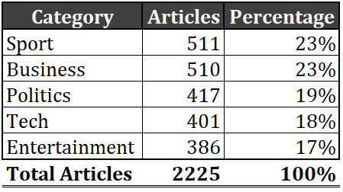
Sport and Business have the highest number of articles, each slightly above 500, while Entertainment has the fewest at 386. Despite minor differences, the distribution is reasonably balanced, ensuring that each category is sufficiently represented for both sentiment analysis and topic modeling.
Interpretation
The relatively even spread of documents across categories indicates a well-structured dataset. Each editorial domain contributes several hundred articles, which provides:
- Enough linguistic diversity within categories to reflect their thematic depth.
- Enough volume across categories to support fair comparisons.
- A strong foundation for observing meaningful differences in tone, vocabulary, and thematic composition.
This balanced structure enhances the reliability of the analytical results presented in the following sections.

5.2 Sentiment Analysis Results
Sentiment analysis was performed using the Bing lexicon, which classifies words into two categories: positive and negative. For each article, the total number of positive and negative words was counted, and a net sentiment score was computed as:
net sentiment = positive − negative
These document-level scores were then averaged within each BBC news category to determine the overall tone of reporting across the corpus. The resulting category-level sentiment summary is presented below:
Table 2: Sentiment Analysis
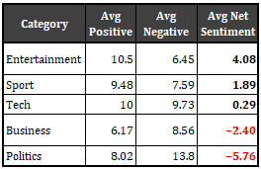
Figure 2: Dot plot Net Sentiment Analysis
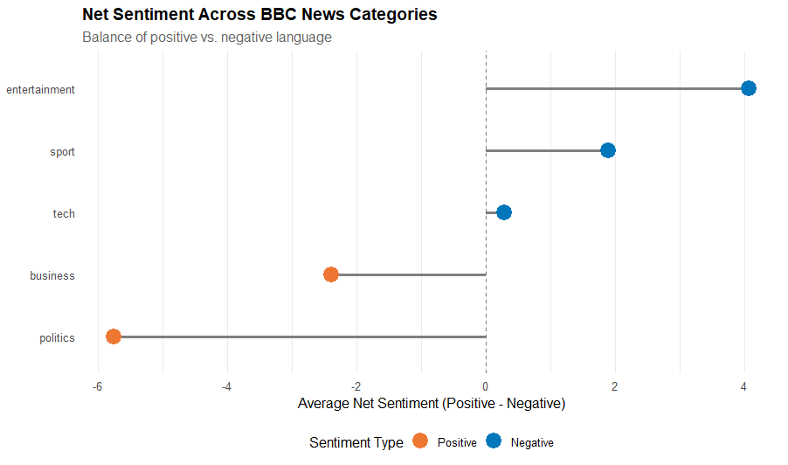
The lollipop plot provides a clear visual comparison of sentiment polarity across categories.These results show a clear gradient of sentiment across the five categories, revealing significant differences in the tone of reporting.
Interpretation
The sentiment patterns observed align with general expectations in some areas while diverging in others:

Entertainment (+4.08) – Most Positive
Entertainment articles use the highest proportion of positive language. This is consistent with content centered on awards, film releases, music events, and celebrity features, all of which tend to emphasize success, creativity, and recognition.

Sport (+1.89) – Strong Positive Tone
Sport emerges as the second-most-positive category. This reflects frequent coverage of wins, achievements, and events that generate excitement. Interestingly, this strong positivity is somewhat unexpected given that sports news also includes losses, injuries, and controversies. Despite this, the sentiment lexicon indicates that BBC sports reporting tends to highlight triumphs and performance over setbacks.

Tech (+0.29) – Near Neutral
Technology articles exhibit a balanced mix of positive and negative language. This suggests that BBC tech reporting covers both opportunities (innovation, new devices, growth) and challenges (security risks, data breaches, failures) in roughly equal measure.

Business (−2.40) – Moderately Negative
Business articles contain more negative than positive terms. This trend is likely driven by content related to market volatility, financial loss, competition, bankruptcies, or declining performance—topics where negative vocabulary is common.

Politics (−5.76) – Most Negative
Political articles show the strongest negativity. This is unsurprising given frequent reporting on conflict, criticism, public dissatisfaction, scandals, policy disagreements, and election-related debates. Politics often involves contentious issues, leading to higher negative word frequencies.
Summary of Sentiment Findings:

Overall, the sentiment analysis reveals that:

- Entertainment and Sport are the most upbeat categories.
- Technology is broadly neutral.
- Business and Politics skew negative, with politics being the most negative overall.
- These patterns reflect differences in content focus and the emotional tone expected in each news domain.

This baseline understanding of sentiment provides important context for interpreting the thematic patterns uncovered by LDA topic modeling in the next section.

5.3 Surprising Result

Although some sentiment differences across categories aligned with expectations, one result stood out as notably unexpected:

Sports articles displayed a significantly positive tone, with an average net sentiment of +1.89, making them the second most positive category after entertainment.

At first glance, this is counterintuitive. Sports reporting often covers both wins and losses, injuries, retirements, controversies, and team conflicts—events that could reasonably produce a mix of positive and negative sentiment. One might expect sports coverage to be emotionally balanced or even slightly negative due to competitive outcomes and performance critiques.

However, the sentiment analysis revealed that positive vocabulary appears much more frequently than negative terms in sports reporting. Words associated with victory, success, achievement, and performance—such as win, first, world, team, and champion—dominate the category. This suggests that BBC sports journalism tends to highlight accomplishments, high points, and competitive excitement rather than dwelling on setbacks or failures.

This finding is significant because it illustrates how the editorial framing of a news domain can shape the emotional tone of coverage. In the context of this corpus, sports emerges not merely as a domain of competition and conflict but as a space where positive events and outcomes receive greater emphasis than negative ones.

This insight deepens our understanding of how sentiment varies across news categories and underscores the value of computational text analysis in uncovering subtle patterns that may not be immediately apparent through traditional reading.

5.4 Topic Modeling Results (LDA)

To uncover the latent thematic structure of the BBC News corpus, a Latent Dirichlet Allocation (LDA) model was applied using k = 5 topics. This number was chosen to align with the five editorial categories present in the dataset and to evaluate whether the algorithm could recover these themes purely from word co-occurrence patterns, without any predefined labels.

The LDA model produced five coherent topics, each represented by the ten highest-probability terms (β values). Notably, the exclusion of high-frequency function words and reporting verbs during preprocessing (Section 4.2) allowed each topic to be represented by substantive, domain-specific vocabulary rather than generic news terminology.

These terms serve as the strongest indicators of each topic. The resulting topic-term plot is shown in Figure 3.

Figure 3: Bar chart LDA top terms
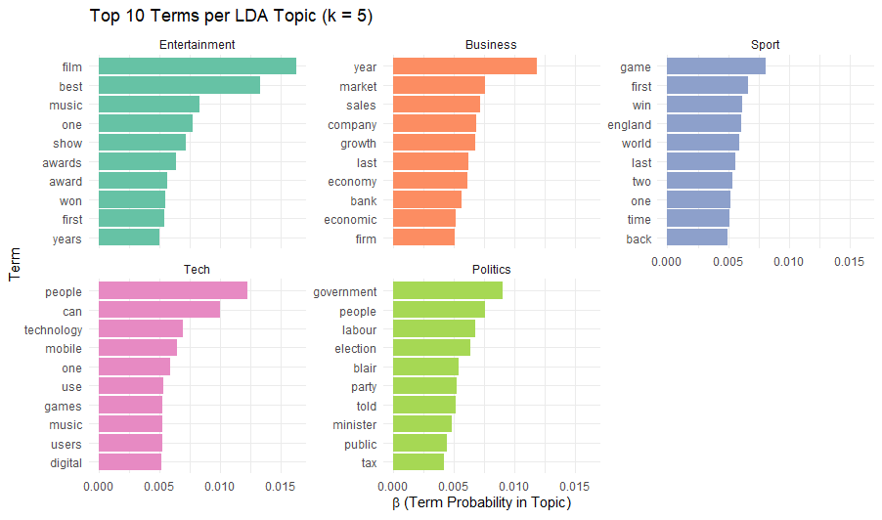

Topic Interpretations
Topic 1 – Entertainment & Film Media

Top terms: film, best, music, one, show, awards, award, won, first, years
This topic is clearly associated with entertainment and cultural reporting. The presence of words such as film, music, show, and awards reflects coverage of artistic productions, performances, and industry recognition.

Topic 2 – Business and Economic Activity

Top terms: year, market, sales, company, growth, last, economy, bank, economic, firm
This topic reflects business reporting, with vocabulary related to markets, corporate performance, economic activity, and financial institutions. Words such as market, sales, company, and economy indicate discussion of economic conditions and business outcomes. This topic aligns clearly with the business category.

Topic 3 – Sports and Competition

Top terms: said, game, first, england, win, world, last, two, one, time
This topic includes vocabulary commonly found in sports reporting: game, win, first, world, england, and match-related numbers such as one and two. These terms reflect match outcomes, competitive performance, and tournament coverage. This topic aligns with the sport category.

Topic 4 – Technology and Digital Culture

Top terms: people, can, technology, mobile, one, use, games, music, users, digital
This topic blends general human-centered language with technology-specific vocabulary. Terms such as technology, mobile, digital, and users point to reporting on devices, consumer tech, and digital services. Meanwhile, words like people and use reflect discussions about how technologies impact daily life. The presence of games and music further suggests coverage of digital media ecosystems. As a whole, this topic aligns with the tech news category.

Topic 5 – Politics and Government Affairs

Top terms: government, people, labour, election, blair, party, told, minister, public, tax
This topic is dominated by political terminology. Words such as government, election, labour, and party indicate reporting focused on political institutions, campaigns, and public policy. Names like Blair anchor the topic in UK political leadership, reflecting issues relevant to the time period of the dataset. Terms such as minister and public further reinforce the governmental and civic focus. This topic clearly corresponds to the politics category.

Overall Interpretation
The LDA model successfully uncovered five distinct and semantically coherent topics, each of which maps closely to a major editorial section of the BBC. This is noteworthy because:

- The algorithm was not provided with category labels.
- Topics emerged naturally based on word co-occurrence patterns.
- The resulting themes match the BBC’s original structure with high fidelity.

This indicates that the BBC corpus is highly organized, with clear linguistic signals differentiating each news genre. It also demonstrates that the preprocessing steps—such as tokenization, stopword removal, and frequency trimming—effectively preserved meaningful patterns while reducing noise.

The clarity of the topics further reinforces the sentiment findings, as each thematic domain exhibits its own characteristic vocabulary that shapes tone, coverage style, and emotional framing.

5.5 Most Frequent Words by Category
To further explore the linguistic patterns within each editorial section, the analysis examined the most frequently used content words after removing stopwords and short tokens. This provides insight into the vocabulary that dominates each domain and helps confirm whether the themes discovered through LDA match the actual lexical structure of the corpus.
Figure 4 – Bar chart Frequent Words by News Category
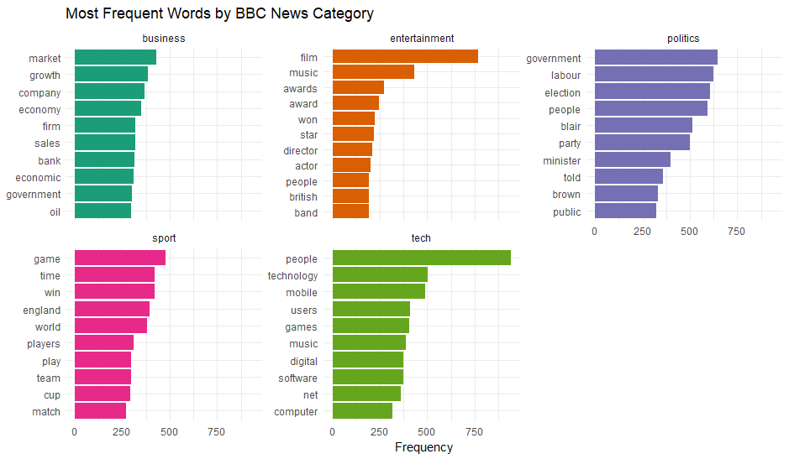
Category-Level Interpretations
Business
Words such as market, growth, company, firm, economy, sales, and bank appear most frequently. These terms reflect reporting on financial performance, economic trends, corporate activity, and market conditions. The presence of oil and government indicates coverage of economic policy and commodity markets.

Entertainment
This category is dominated by terms like film, music, award, director, star, actor, and won. These words clearly relate to the entertainment industry, including film releases, performances, creative arts, media events, and award ceremonies.

Politics
High-frequency political terms include government, labour, election, blair, party, minister, and public. These terms highlight the dataset’s strong focus on governmental actions, public policy, elections, political figures, and national leadership.

Sport
Common sports-related words include game, win, england, team, cup, world, play, and players. These terms signal match results, team performance, national competitions, and tournament news—closely matching the sports category’s content style.

Tech
Frequent words include technology, mobile, users, digital, software, phone, net, and games. These terms reflect coverage of digital devices, tech innovation, consumer electronics, and the broader technology ecosystem.
Interpretation and Significance
The most frequent words in each category are:
- Highly domain-specific
- Consistent with the LDA topic assignments
- Emotionally aligned with the sentiment results
- Representative of the vocabulary readers associate with each domain
This strong lexical coherence shows that:
- The BBC corpus is linguistically well-structured.
- Preprocessing successfully isolated meaningful content words.
- LDA uncovered themes that reflect actual vocabulary usage.
- Each category has a distinct linguistic fingerprint.
For example, the dominance of games, win, and team in the sport category complements the positive sentiment score for sports, while the emphasis on government, minister, and election in politics supports its status as the most negative category. The business category’s focus on market, growth, and firm aligns with its moderately negative tone, reflecting economic risks and performance pressures.

5.6 Global Word Cloud
In addition to category-level visualizations, a global word cloud was created to summarize the most frequently occurring words across the entire BBC corpus. These visual aggregates all cleaned tokens—after removing stopwords, punctuation, numbers, and very short terms—and displays them with sizes proportional to their frequency.
Figure 5: Global Word Cloud
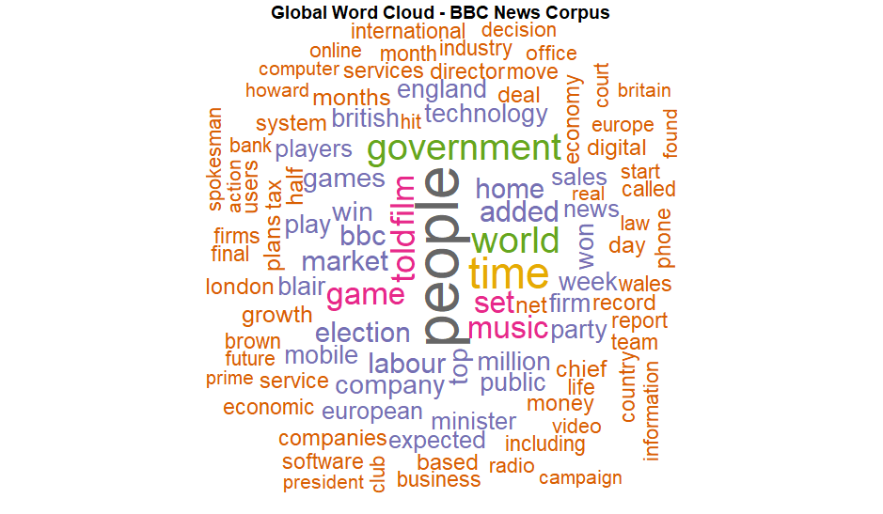
The word cloud highlights the prominence of several frequently used terms, including people, government, film, world, time, market, game, and music. These words represent concepts that recur throughout the news articles, regardless of category.
Interpretation
The global word cloud provides insight into the overall thematic landscape of the corpus:

- “People” as the Most Dominant Term
The word people appear across all categories, reflecting the human-centered nature of news reporting. Whether discussing political decisions, business impacts, cultural events, or sports achievements, BBC articles frequently reference individuals, groups, and the public at large.

- High-Level News Themes
The prominence of words like government, world, and market indicates that the corpus includes substantial coverage of policy decisions, global events, and economic conditions. These terms are central to news narratives and often anchor broader topics across multiple categories.

- Category-Specific Vocabulary Appearing Globally
Terms such as film, games, and music—although characteristics of entertainment and sports—are sufficiently frequent to appear in the global cloud. This suggests that these topics generate a large volume of articles and that their vocabulary carries substantial weight in the overall corpus.

- Complementarity with LDA and Sentiment Analysis
The global word cloud aligns with both the LDA and sentiment findings:
- Entertainment terms (film, music) reinforce the strong entertainment topic.
- Business terms (market, company) align with the business theme.
- Politics terms (government) reflect the negative sentiment profile of political coverage.
- Sports terms (game, win) correspond with the surprisingly positive sentiment in the sports category.
This supports the conclusion that the thematic and emotional patterns uncovered by computational methods are grounded in the actual frequency and usage of words across the corpus.

6. Conclusion
This project applied text analytics techniques—including sentiment analysis, descriptive linguistic statistics, and topic modeling—to a corpus of 2,225 BBC news articles spanning business, entertainment, politics, sport, and technology. The goal was to examine how emotional tone varies across the BBC’s editorial domains and to uncover the underlying thematic structure of the corpus without relying on predefined labels.
The sentiment analysis revealed clear and meaningful differences across categories. Entertainment and sport emerged as the most positive sections, with entertainment achieving the highest average net sentiment. Technology reporting was largely neutral, reflecting a balance between innovation-focused optimism and discussions of risks or technical challenges. In contrast, business and politics were predominantly negative, with politics showing the strongest negative sentiment—a pattern consistent with reporting on elections, public policy debates, and governmental conflict. A particularly surprising finding was the degree of positivity in sports reporting, suggesting that BBC sports articles tend to frame competitions in terms of achievements, highlights, and victories rather than losses or setbacks.
The topic modeling results reinforced these findings. The LDA model, configured with five topics, produced coherent thematic groups that aligned closely with the actual BBC categories. Each topic was characterized by highly domain-specific vocabulary: film and music for entertainment, market and company for business, games and team for sports, technology and mobile for tech, and government and election for politics. The clarity of these topics indicates that the BBC corpus has strong internal structure and that the text preprocessing steps effectively preserved meaningful linguistic patterns.
Finally, the frequency analysis and global word cloud provided additional confirmation of the thematic and emotional structure across categories. High-frequency terms were closely aligned with expected content domains, while the global cloud highlighted common cross-category themes such as people, government, world, and time—core elements of news reporting.
Overall, the analysis demonstrates that text mining methods can uncover both high-level thematic organization and category-specific tone within large text corpora. The consistency between sentiment results, topic modeling output, and frequency-based visualizations indicates that the BBC News Summary dataset is well-suited for computational linguistic analysis. Future work could extend this project by exploring more granular sentiment models, using bigrams or trigrams to capture context, or applying time-series text analysis to examine how tone evolves during major events.

Reference:
Maier, D., Waldherr, A., Miltner, P., Wiedemann, G., Niekler, A., Keinert, A., Pfetsch, B., Haim, M., Kruschinski, S., Wüst, B., & Adam, S. (2018). Applying LDA topic modeling in communication research: Toward a valid and reliable methodology. Communication Methods and Measures, 12(2-3), 93-118. Silge, J., & Robinson, D. (2017). Text Mining with R: A Tidy Approach. O'Reilly Media. https://doi.org/10.1080/19312458.2018.1430754

